Assessment: QA Library project
Candidate Instructions
Candidates are advised to read all instructions carefully before starting work.
Approximate duration: 4 hours
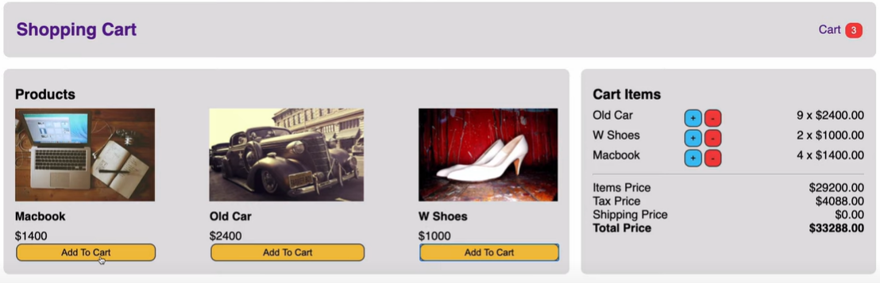
Scenario
You have been tasked to build a website using React and HTML5, Css3 that allows customers to:
- Selected a product that are available for purchase into their shopping basket
- Adjust the quantity of a product they order
- Place an order for their basket by providing their customer information
Install the database
- Use the productsJsonServer.json file to install an API that exposes a list of product details.
The API will contain information about the products with the following attributes shown below as an example:
{
"id": 1,
"ProductName": "Chai",
"UnitPrice": 18,
"UnitsInStock": 39,
"Suppliers": [
{
"CompanyName": "Exotic Liquids"
}
]
}
The root name is products
Design the website
- Use a JSON server to create an API for the products.
- Create a welcome page with some interesting detail about your company! Any information will do but you have an opportunity to add some of the interesting effects which we discussed during the course.
- Create a link on the Welcome page to show a list of products. You will need to call your Jason server API to get the list. Display only the ProductName and UnitPrice using a list. You may choose any design you like. You can use active links, buttons, icons… beside each product in order to select that product.
- When a product is selected, it is added to a shopping basket
Tip: use localStorage to add a Shopping basket Item.
You may need to create a class for this object.
- If the same item is selected the quantity of the item is increased by 1.
- Customers should not be able to order more items than we have in stock (see the UnitsInStock attribute)
- Make sure users are informed of any update to their order.
- Create a link to the customer's shopping basket.
The link should not be active when the shopping basket is empty
- When the shopping basket is displayed, allow the customer to increase or decrease quantity ordered. Remove the item if the quantity is zero.
- Don't forget to display the total basket cost when displaying the basket details.
- Create a link on the shopping basket to buy more products.
- Create a link on the shopping basket to pay. You will not implement any payment.
- Shopping basket is cleared when the customer pays for the items.
Don't forget to adjust the UnitsInStock attribute for each shopping basket item
- As an optional step you may ask the customers for their name and address.
- As another optional step, you may want to save details of any paid order.
Clearly, there is more to an eCommerce site, such as multiple customers buying the same item, user registration, security and so on.
Our Jason server simulates the APIs, but in reality, you will use a server-side database. However, you only have one day, and you will need a few more days in order to compete with Amazon!
END

